STATEMENT OF COMPLIANCE
SHORT TERM CERTIFICATE OF FITNESS FOR THE CARRIAGE OF DANGEROUS CHEMICALS IN BULK


Issued under the provisions of the
Code for the Construction and Equipment of Ships Carrying Dangerous Chemicals in Bulk
(Resolutions MSC.9 (53) and MEPC.20 (22) as amended) As per request of:

THE OWNER
By GR CLASS CLASSIFIED FOR STANDARD (GR CLASS)
SOC-BCH No.

Name Ship | Distinctive number or letters | Port of registry | Gross tonnage
 | IMO Number:

Date on which keel was laid or ship was at a similar stage of construction or, where applicable, date on which work for a conversion or an alteration or modification of a major character was commenced:
(YYYY-MM-DD)

The ship also complies fully with the following amendments to the Code: The ship is exempted from compliance with the following provisions of the Code:
THIS IS TO CERTIFY:

- That the ship has been surveyed in accordance with the provisions of section 1.6 of the Code.
- That the survey showed that the construction and equipment of the ship and the condition thereof are in all respects satisfactory and that the ship:
  - complies with the relevant provisions of the Code applicable to ships referred to in 1.7.2;
  - complies with the relevant provisions of the Code applicable to ships referred to in 1.7.3;
- That the ship has been provided with a manual in accordance with Appendix 4 of MARPOL Annex II as called for by regulation 14 of the Annex, and that the arrangement and equipment of the ship prescribed in the Manual are in all respects satisfactory.
- That the ship meets the requirements for the carriage in bulk of the following products provided that all relevant operational provisions of the Code and MARPOL Annex II are observed.

Products | Conditions of Carriage (tank numbers, etc.) | Pollution Category
Continued on attachment 1, additional signed and dated sheets1
Tank numbers referred to in this list are identified on attachment 2, signed and dated tank plan.

- That, in accordance with 1.7.3 / 2.2.52, the provisions of the Code are modified in respect of the following manner:

1 Delete as appropriate.
2 Delete as appropriate

- That the ship must be loaded:

  - In accordance with the loading conditions provided in the approved loading manual, stamped and dated
and signed by a responsible officer of the Administration, or of an organization recognized by the Administration2

  - In accordance with the loading limitations appended to this certificate2

Where it is required to load the ship other than in accordance with the above instruction, then the necessary calculations to justify the proposed loading conditions should be communicated to the certifying Administration who may authorize in writing the adoption of the proposed loading condition3.

This certificate is valid until
(DD-MM-YYYY)
Completion date of the survey on which this certificate is based
(DD-MM-YYYY)

Issued at |  | Date of issue
 | (Place of issue of certificate) | (DD-MM-YYYY)

GR CLASS REPRESENTATIVE

Notes on completion of Certificate:
- The Certificate can be issued only to ships entitled to fly the flags of States which are a Party to MARPOL 73/78.

- Ship Type: Any entry under this column must relate to all relevant recommendations, e.g., an entry “Type 2” should mean Type 2 in all respects prescribed by the Code. This column would not usually apply in the cases of an existing ship and in such a case should be noted “see paragraph 2.2”.

- Products: Products listed in chapter 17 of the Code, or which have been evaluated by the Administration in accordance with 1.8 of the Code, should be listed. In respect of the latter “new” products, any special requirements provisionally prescribed should be noted.

- Product s: The list of products the ship is suitable to carry should include the noxious liquid substances of Category Z which are not covered by the Code and should be identified as “chapter 18 Category Z”.

- Conditions of carriage: If a Certificate is issued to a ship which is modified in accordance with the provision of regulation 1(12) of MARPOL Annex II the Certificate should indicate in the top of the table of products and conditions of carriage the following statement. “This ship is certificated to carry only pollution hazard chemicals”.

3 Instead of being incorporated in the Certificate, this text may be appended to the Certificate if signed and stamped.

GR CLASS CLASSIFIED FOR STANDARD (GR CLASS)
SHORT TERM CERTIFICATE OF FITNESS FOR THE CARRIAGE OF DANGEROUS CHEMICALS IN BULK

ATTACHMENT No. 1

Continued list of products to those specified in section 3, and their conditions of carriage.

SOC-BCH No.

Products | Conditions of Carriage (tank numbers, etc.) | Pollution Category

Issued at |  | Date of issue
 | (Place of issue of certificate) | (DD-MM-YYYY)

GR CLASS REPRESENTATIVE

GR CLASS CLASSIFIED FOR STANDARD (GR CLASS)

SHORT TERM CERTIFICATE OF FITNTESS FOR THE CARRIAGE OF DANGEROUS CHEMICALS IN BULK

ATTACHMENT No. 2 TANK PLAN
SOC-BCH No.
Name of ship
Distinctive number or letters:
IMO Number

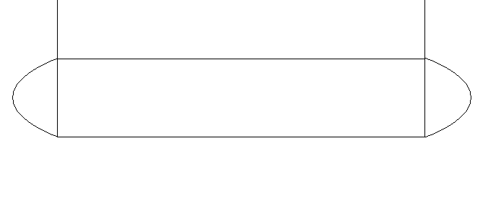
Cargo area

Issued at |  | Date of issue
 | (Place of issue of certificate) | (DD-MM-YYYY)

GR CLASS REPRESENTATIVE

